User Manual
GALAXY : Glycoanalysis by the three axes of MS and chromatography.
Index:-
- Display
  - Start Up Screen
  - Graph Selection
  - Text Fields
  - Manually inserted Data Display
  - Mouse Click
  - ZOOM++ / ZOOM--
  - Code No. Search
  - Product / Precursor selection
  - Product / Precursor Display
  - Color classification
  - Graph movement
  - Mouse Double Click
  - Right Click Menu
  - DreeDraw

- Information Page
- Customer Support

- Display

  - Start up Screen

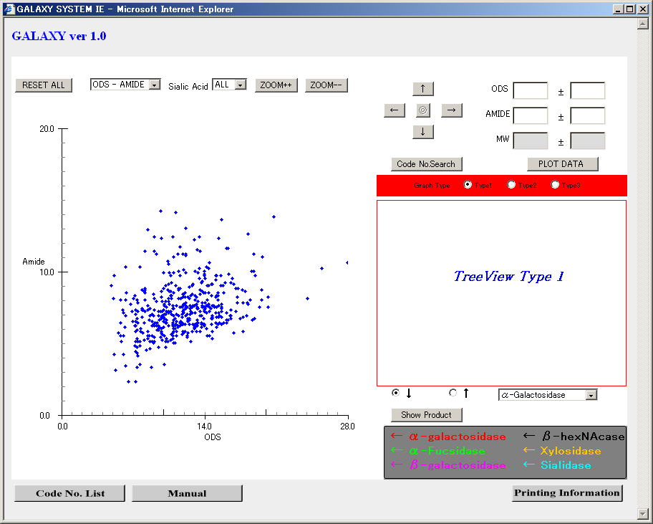

This screen is the basic view of the system displaying various tools available with this system. The system display consists of various text field, buttons, combo boxes and checkboxes for user to select different options and perform various functions.
The graph display will be always limited to the black lines representing graph divisions (Max. length is shown by arrows in above figure).

  - Graph Selection

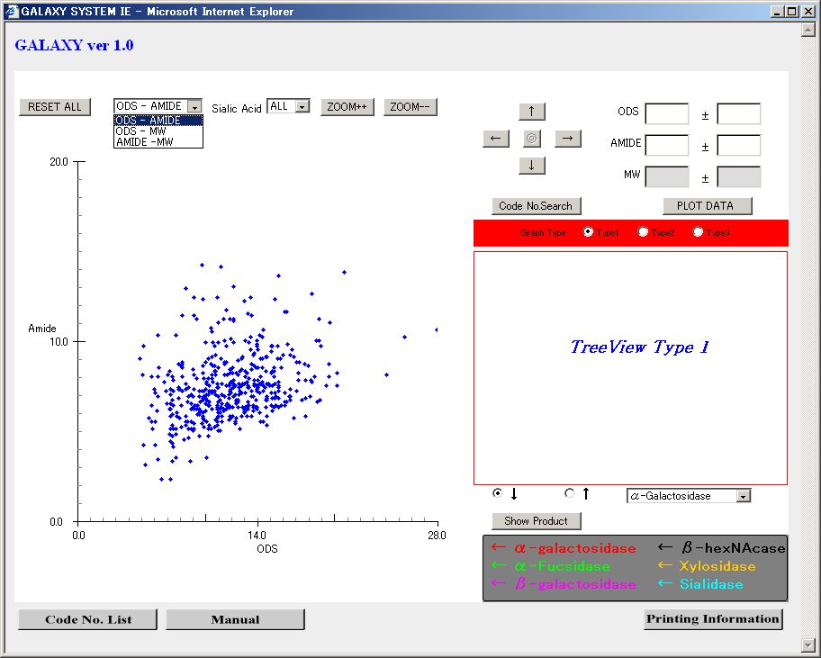

By clicking the choice box at the left corner of the screen, one of the three types of graphs can be selected. By default ODS - Amide graph is selected and the same graph is displayed on the screen

Similarly by clicking on the Sialic Acid choice box, one of the SIX(6) types of the Sialic Acid can be selected. By default “all” is selected and the graph is drawn.

  - Text Fields

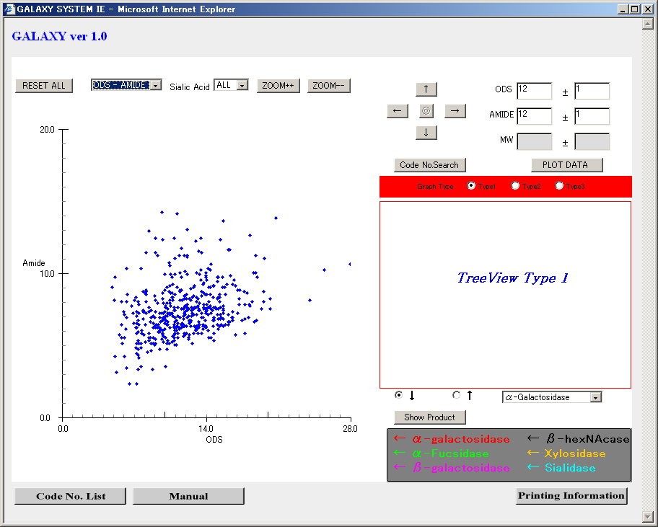

Text Fields are available for manually entering the Data. Text Fields representing the X and Y entities of the graph have white background and the Text Fields, which does not represent either of the selected graph type, have gray background.

  - Manually inserted Data Display

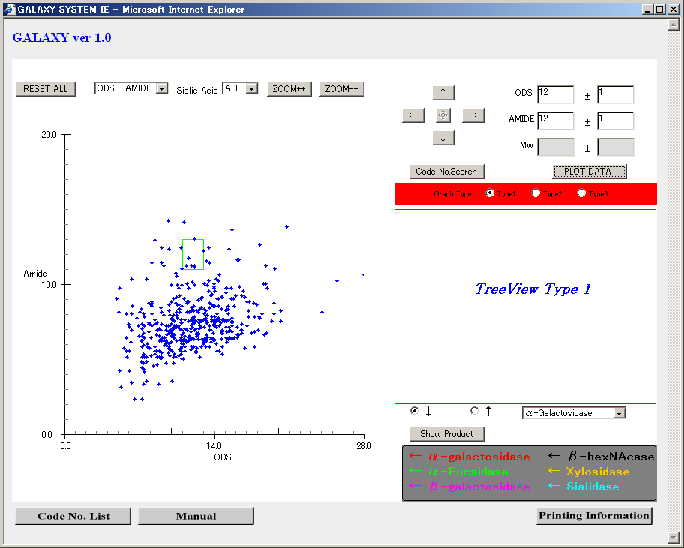

To display the Text Field data in the current graph click the “PLOT DATA” button. According to the values entered in the Text Field various shapes are created as follows:
- X entity － a green line at the X value
- Y entity － a green line at the Y value
- X and Y entities －: `+` sign with intersection as X and Y point.
- X entity and X error － 3 green lines with center line at X value and 2 green lines at the (X + error) and (X－error) each.
- Y entity and Y error － 3 green lines with center line at Y value and 2 green lines at the (Y + error) and (Y－error) each.
- X, Y and one error Field－: One green line with X,Y as center and length equal to error value.
- X,Y and both error fields－: Rectangle

  - Mouse Click

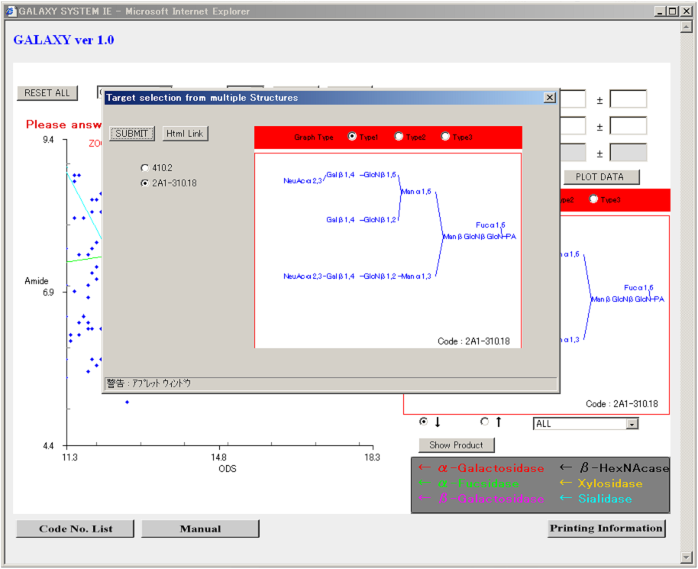

Mouse Single Click is used to perform various functions as follows:
PA-glycan Selection- Click on one of the blue points. If the selected PA-glycan is present in the data set of the System red point will be displayed on the screen at the mouse click. If the clicked data is not available with the System, a red plus sign will be displayed with center as the clicked point. Red circle means data is available with the System and red plus sign means unavailability of the selected data.

Single PA-glycan selection from Multiple PA-glycan of the same values but different Structures. As shown in the figure above, if clicked PA-glycan has multiple Structures, new dialogue will be popped up. This dialogue contains code numbers of all the PA-glycan`s having same values but different structures. User can select any PA-glycan by selecting radio button associated with particular Code Number. In the dialog structure of the selected code number is displayed. Selected Structure will be displayed in the graph by pressing “Submit” button.

  - ZOOM++ / ZOOM--

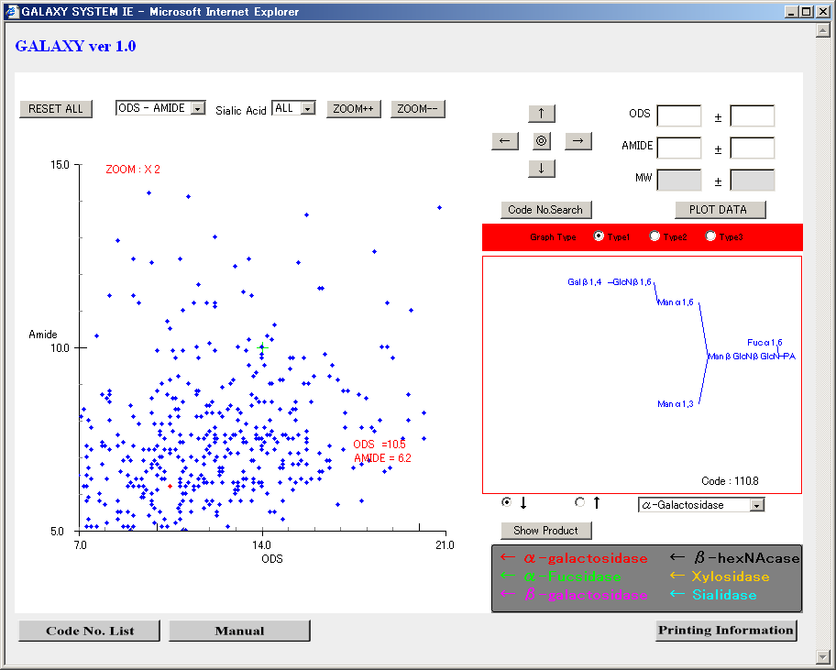

The graph contents can be zoomed by pressing the Zoom++ button. The maximum zoom is up to X8. The contained point values are limited to graph limits. Zoom is always carried out with respect to the center point of the graph.
Example: In the image shown above RED POINT represents the point selected by the user. In above case the zoom will be done according to y (amide) = 10.0 and x (ODS) = 14.0
Tip: To zoom with respect to the selected point, select the point and press Center button(◎(Circle in circle)). This will bring the selected point to the center of the graph. Then press the ZOOM++ button.
Zoom-- button is used to decrease the zoom. The user can decrease the zoom upto the basic graph limit. To effect this button the graph must be zoomed first. Only zoomed graph can be unzoomed using ZOOM―― button.
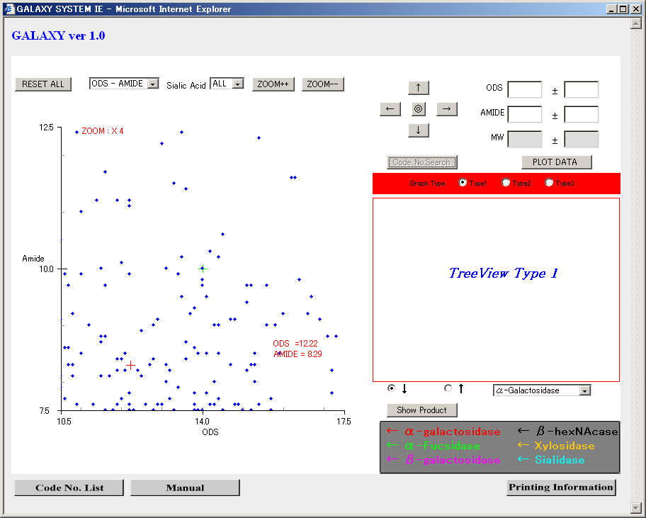
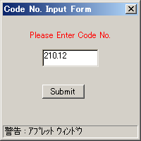
  - Code No. Search

This button is used to search the PA-glycan according to code number associated with that PA-glycan. On pressing this button, new dialog will pop up and user can enter the Code to be searched, in the text field of the popped up dialog and click submit button or press Enter. If the code entered by the user is available in the data, the product representing that code will be selected (that point will become red) else error message will be displayed.
Once this button is pressed a dialog box will pop up and THE BUTTON WILL BE DISABLED UNTIL USER CLEARS THE POPPED UP DIALOG.

  - Product / Precursor Selection

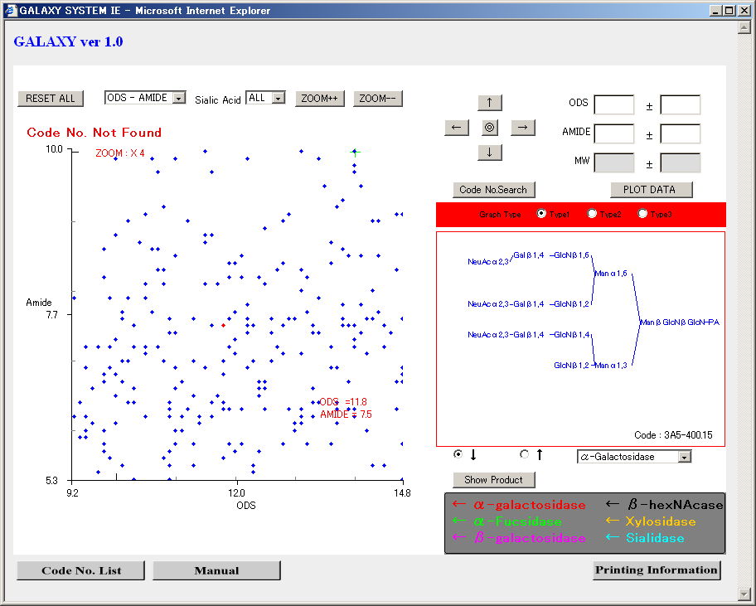

These checkboxes are used for the product and Precursor selection. The default selection is SHOW PRODUCT (downward arrow). For Precursor simply click the other checkbox and select the precise enzyme. Then press Precursor button.

  - Product / Precursor Display

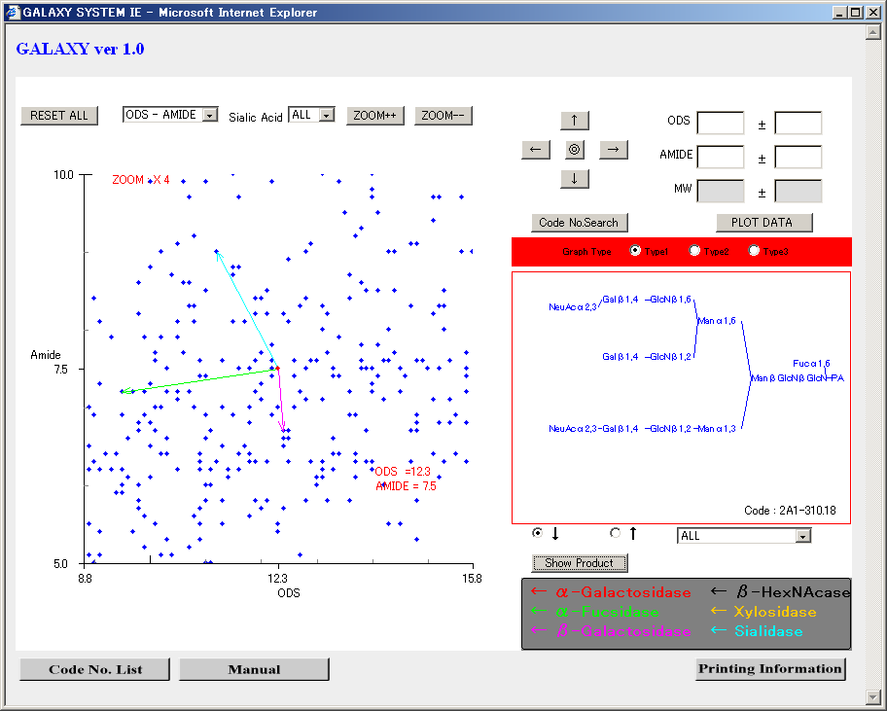

This button is used to draw product and Precursor arrows according to the selection of checkboxes. If the product checkbox (downward arrow) is selected this button will read as Show Product. If Precursor checkbox is selected (downward arrow), this button will read as Precursor. Select the appropriate checkbox. Select appropriate enzyme type and press this button.
In Show Product case if the product is available with the selected enzyme, an arrow will be drawn else error message will be displayed. If selected Oligosaccharide has a cut site but the product is unknown, a Dialog box will pop up asking whether to display unknown data or not. If the user selects to display data, an arrow (dotted line in this case) will be drawn to the product and as the product is unknown, a black point will be displayed as the product. User can select this product (black point) by clicking mouse on it but can not draw an arrow from this unknown product. User can double click the unknown point to see the Structure associated with this unknown product. If the unknown structure is a multiple point, Multiple point selection dialog will pop up and user can select from the Multiple products (known / unknown).
If from enzyme choicebox ALL option is selected and arrow button is pressed all the products related to all enzyme types are displayed.
If any of the enzyme type product has unknown data dialog will pop up. All the unknown products are shown if the user presses yes button on the dialog window else if the user presses no button none of the unknown products are shown but all the known products are shown.
For displaying the precursor, select an appropriate enzyme from the choice box and press Precursor button. All the precursor products are displayed. Red lines indicate an unknown product and Black lines indicate known products. Here Known product means the products currently available with this system.

  - Color palette

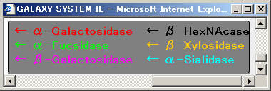

The color of an arrow drawn represents the particular enzyme. The panel shown just below the Product / Precursor button explains the color scheme used with respect to enzyme.
Red – alpha galactosidase
Green – alpha Fucsidase
Magenta – beta galactosidase
Black – beta hexNAcase
Orange – beta Xylosidase
Cyan – alpha Sialidase

  - Graph movement

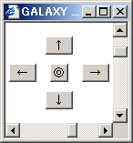

These buttons, except center button (circle in circle), are used to move the graph i.e. graph co-ordinates to left and right (x co-ordinates) or up and down (y co-ordinates).
Center button is used to bring the selected point to the center of the graph. Center button (circle in circle) is disabled when this applet is downloaded.
When user clicks in the graph limits or plots data from text fields, or plots the point according to Code no., this button is enabled and user can set the selected point at the center of the graph.
Rest of the buttons are basically used to locate an arrow head location if its not in graph limits.

  - Mouse Double Click

This option is used to open the “Information Page” (Html link page) of the selected product. Simply select the product and double click on the selected product, it will open a new HTML page which contains detailed information about the selected product.
Tip: In case, if the selected product has multiple points, double click linking is not possible. As soon as such point is clicked it will pop up a dialog to select from the available products representing the same point. In this case to see the “Information Page”(Html link), click mouse’s right button on the point of multiple products (right click on that point), menu bar will pop up. Select Html Link from this Menu Bar. It will open all the Html pages depending on the number of products selected point represents. For example if the point represents 3 products, 3 Html pages, each related to the corresponding structure are displayed.

  - Right Click Menu

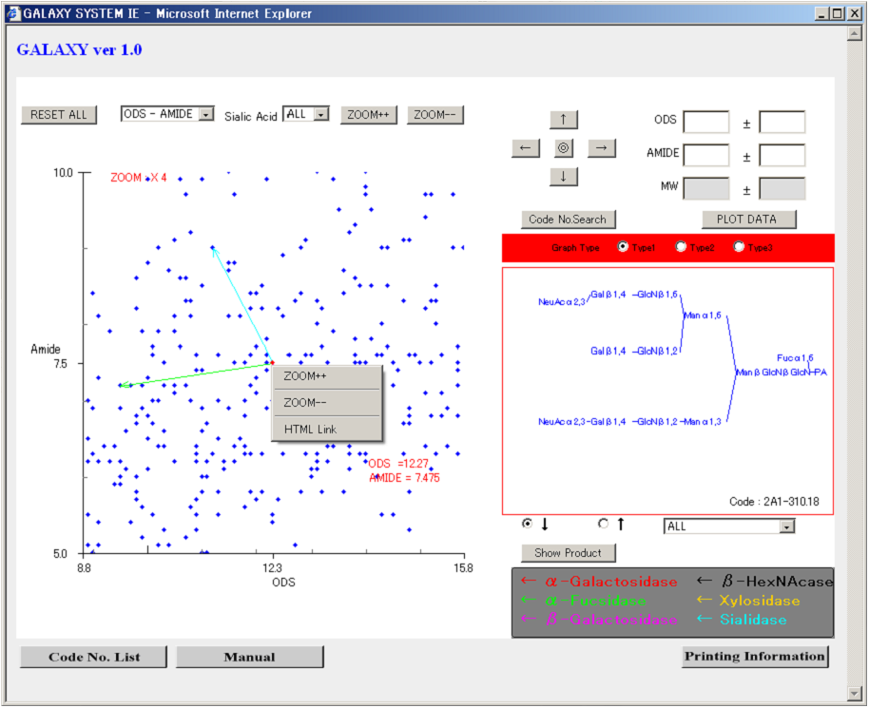

If user right clicks on the selected product, as shown in above figure, a menu bar will pop up. This menu bar has 3 menu items viz. ‘ZOOM++’, ‘ZOOM—‘, ‘HTML Link’. To select any of these menu options, simply click on the desired menu. These menu options will work same as the buttons representing these functions.

  - TreeDraw

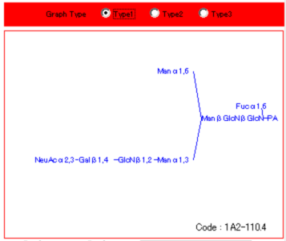
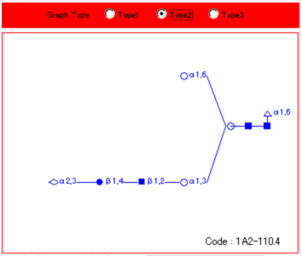
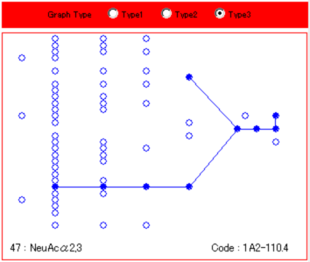
(a) type1

(b) type2

(c) type3

Structure shown at the right lower corner of the System is called TreeDraw.
TreeDraw represents the Structure of the selected PA-glycan. 3 Types of structure presentations are available with this system. User can select any one type at a time by selecting radio button at the top of the tree draw.
Type 1 - Textual representation
Type 2 - Symbolic representation
Type 3 - Complete sugar chain illustration
In type 2 and 3 user can click on the Unit to see the information related to that unit.

２．Information Page

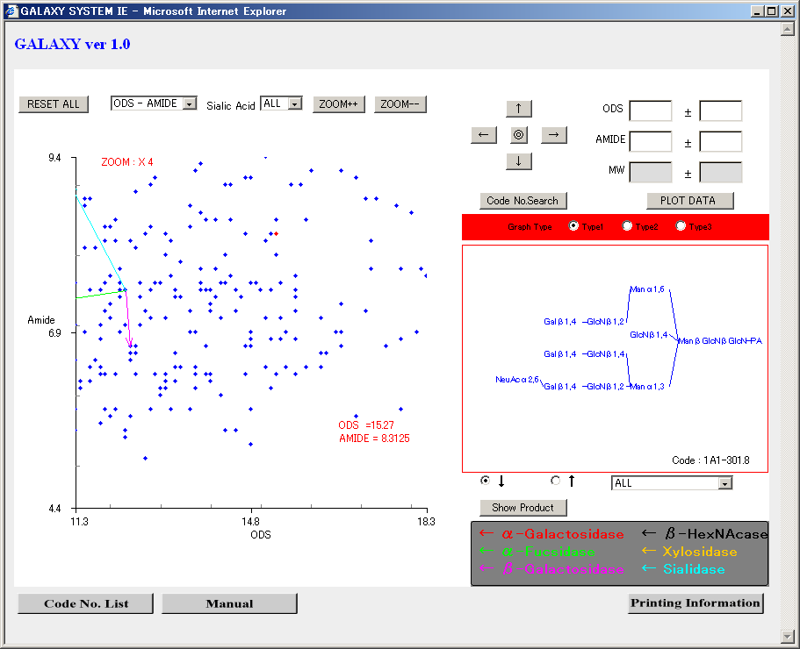
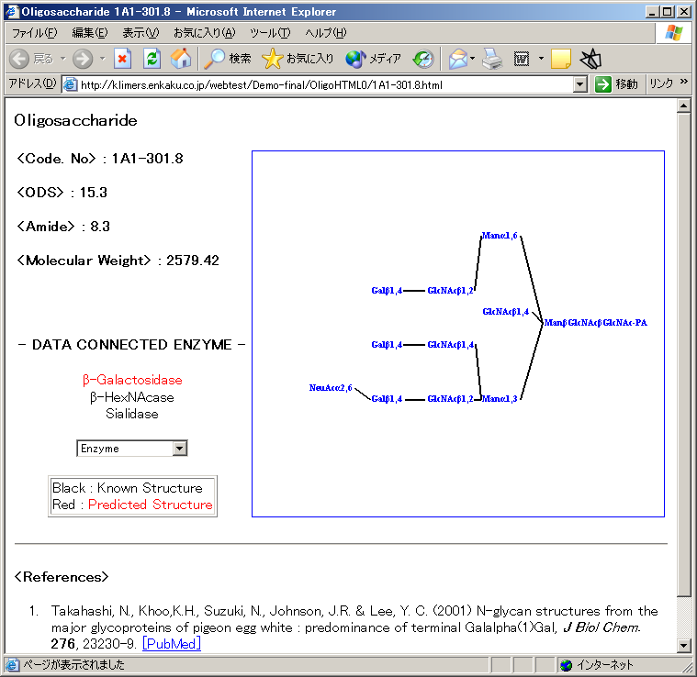
The link related to the particular product is as shown in the above figure. This link is called as “Information page”. This page contains detailed information about the selected procuct.
ODS, Amide, MW values are displayed along with product code number. It also provides the information about the data connected enzyme.
The data connected enzyme list is displayed. User can select the diplayed enzyme from the choice box. The connected structure is displayed according to the selected enzyme.
Enzyme displayed in RED color have unknown data and enzymes
displayed in black color have known products.

3. Customer Support:

In case of System assistance please contact us on +81-6-4792-6088 or Fax at 06-4792-6089.
E - mail us at info@primmune.com
For bug reports please mail at info@primmune.com
If you need more information about this product, download user manual or contact SystemInfo.

――――――――――――――――――――――――――――――――――――――――
Department of Structural Biology and Biomolecular Engineering, Graduate School of Pharmaceutical Sciences, Nagoya City University
Noriko Takahashi
Koichi Kato

Primmune K.K.
Shuzo Sawada
――――――――――――――――――――――――――――――――――――――――

